SECOND ORDER DESIGN EQUATIONS

For the second order transfer function:
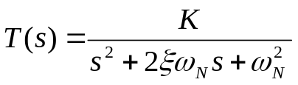

TIME DOMAIN SPECIFICATIONS

a) Peak Overshoot:
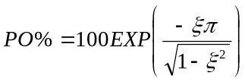
b) Time to peak:
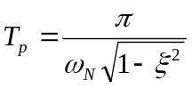
c) Damped frequency of oscillation:
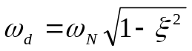

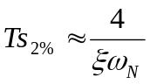d) Settling time to within 2% :
e) Time constant:

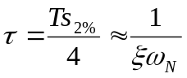

FREQUENCY DOMAIN SPECIFICATIONS

a) Relationship between closed-loop damping factor and phase margin:
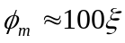

b) Settling time (2%) for closed-loop step response (in seconds):
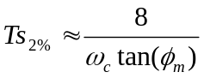

Where ω_{c} is the gain crossover frequency (rad/s) and φ_{m} is the phase margin (in degrees).

